**DRUGS CLASSIFICATION**

**RAGHAV | 20BCE7383**

**INTRODUCTION:**

The aim of drug classification is to make sure you use a drug safely and get the greatest possible benefit. Every time you take a drug, your body chemistry changes.

Medications are meant to help. But they sometimes cause harmful side effects. If you take multiple drugs, they may change each other’s effectiveness. They can also make side effects more severe.

By noting the class of a drug, you and your healthcare team can understand what to expect from it. That includes the risks and which others drugs you can switch to.

**Methodology**

This project is implemented using 4 models:

**Model 1:**

The first model is a Logistic Regression. Logistic regression is **a process of modeling the probability of a discrete outcome given an input variable**. The most common logistic regression models a binary outcome; something that can take two values such as true/false, yes/no, and so on.

Using this model, we got Accuracy score as 0.666667.

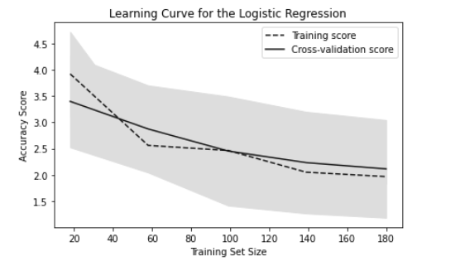

**Model 2:**

The second model is Support Vector Machine (SVM). Support Vector Machine (SVM) is **a supervised machine learning algorithm used for both classification and regression**. Though we say regression problems as well its best suited for classification. The objective of SVM algorithm is to find a hyperplane in an N-dimensional space that distinctly classifies the data points.

Using this model, we got Accuracy score as 1(i.e., 100%).

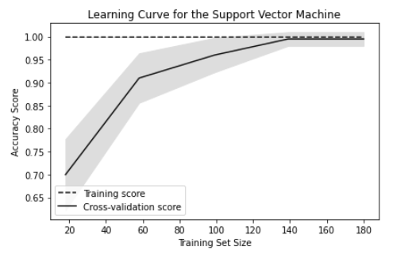

**Model 3:**

The third model is Neural Networks. Neural networks, also known as artificial neural networks (ANNs) or simulated neural networks (SNNs), are **a subset of machine learning and are at the heart of deep learning algorithms**. Their name and structure are inspired by the human brain, mimicking the way that biological neurons signal to one another.

Using this model, we got Accuracy score as 0.866667.

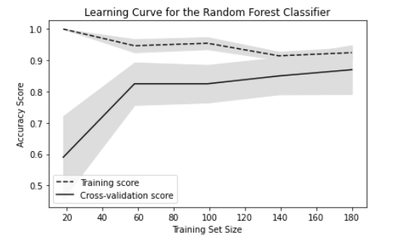

**Model 4:**

The fourth model is Random Forest. Random forests or random decision forests is **an ensemble learning method for classification, regression and other tasks that operates by constructing a multitude of decision trees at training time**. For classification tasks, the output of the random forest is the class selected by most trees.

Using this model, we got Accuracy score as 0.9833333333.

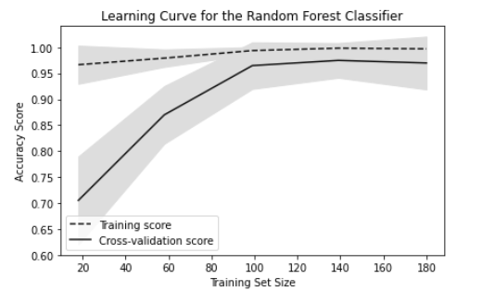

**Results:**

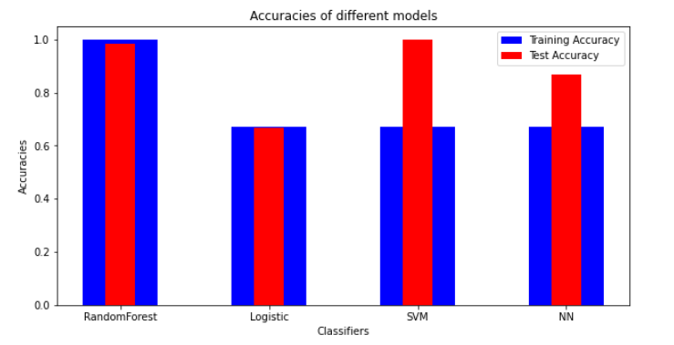

**Conclusion:**

The Random Forest Classifier can be the best among all the four classifiers because it is having both high test and train accuracy.

Though SVM is showing a little more test accuracy than Random Forest, but its train accuracy is too less as compared to its train accuracy, which may make it overfitted.

**Contact Details**

[raghav.20bce7383@vitap.ac.in](mailto:raghav.20bce7383@vitap.ac.in)